**Rename collection:**

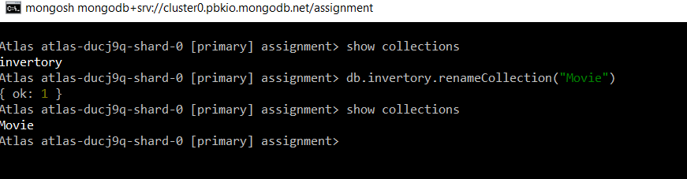

**Insert Documents Insert the following documents into a movies collection.**

title : Fight Club writer : Chuck Palahniuko year : 1999 actors : [ Brad Pitt Edward Norton ] title : Pulp Fiction writer : Quentin Tarantino year : 1994 actors : [ John Travolta Uma Thurman ] title : Inglorious Basterds writer : Quentin Tarantino year : 2009 actors : [ Brad Pitt Diane Kruger Eli Roth ] title : The Hobbit: An Unexpected Journey writer : J.R.R. Tolkein year : 2012 franchise : The Hobbit title : The Hobbit: The Desolation of Smaug writer : J.R.R. Tolkein year : 2013 franchise : The Hobbit title : The Hobbit: The Battle of the Five Armies writer : J.R.R. Tolkein year : 2012 franchise : The Hobbit synopsis : Bilbo and Company are forced to engage in a war against an array of combatants and keep the Lonely Mountain from falling into the hands of a rising darkness. title : Pee Wee Herman's Big Adventure title : Avatar

**1. get all documents**

Answer:

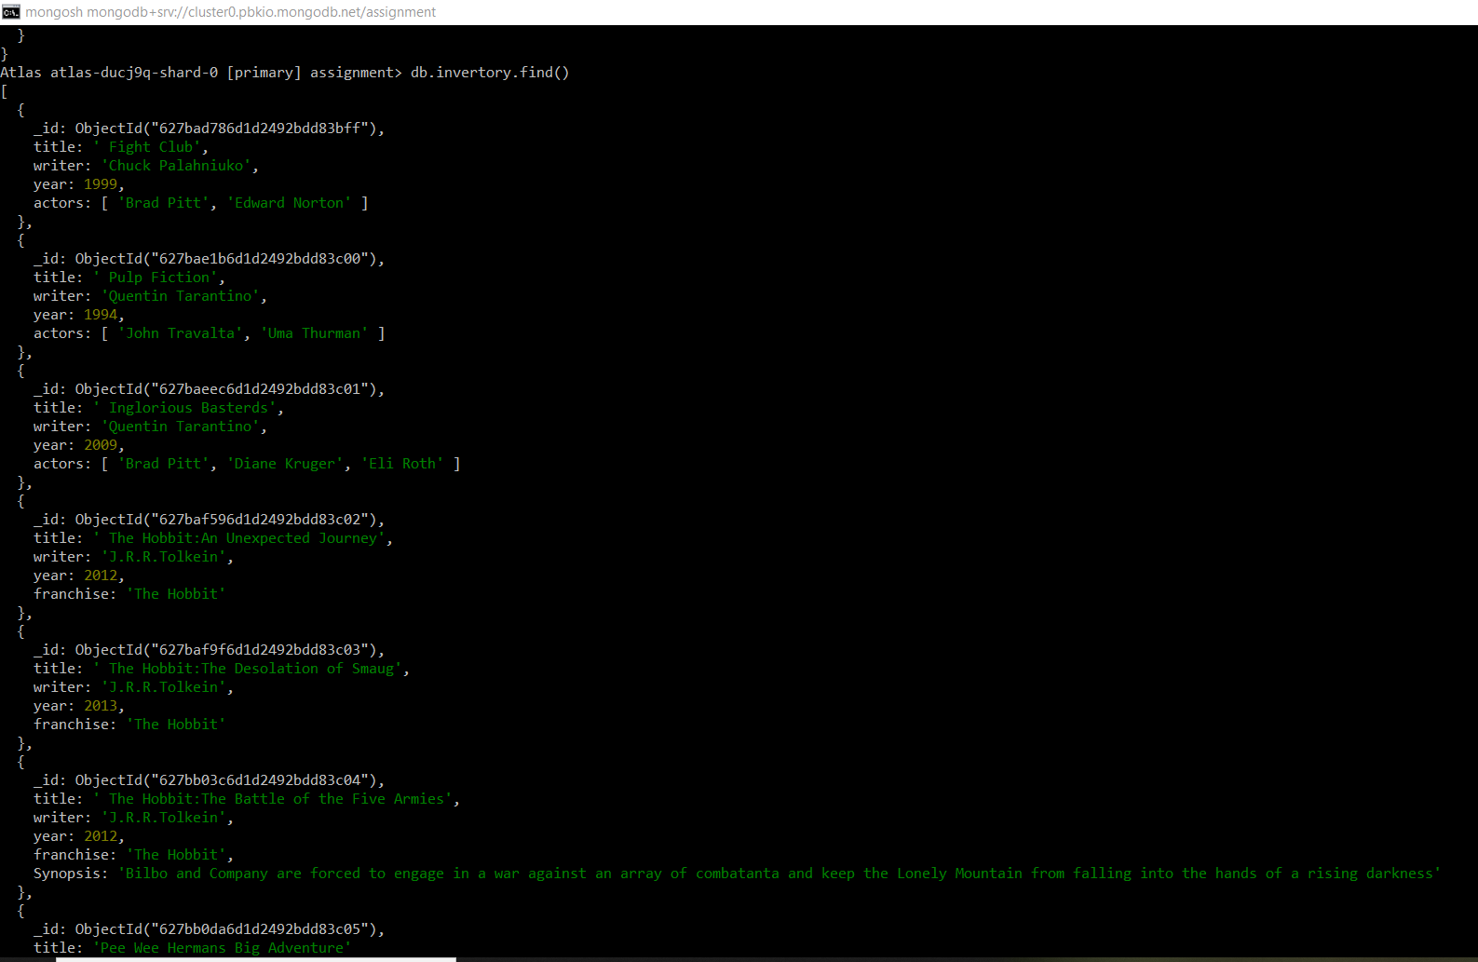

**2. get all documents with writer set to "Quentin Tarantino"**

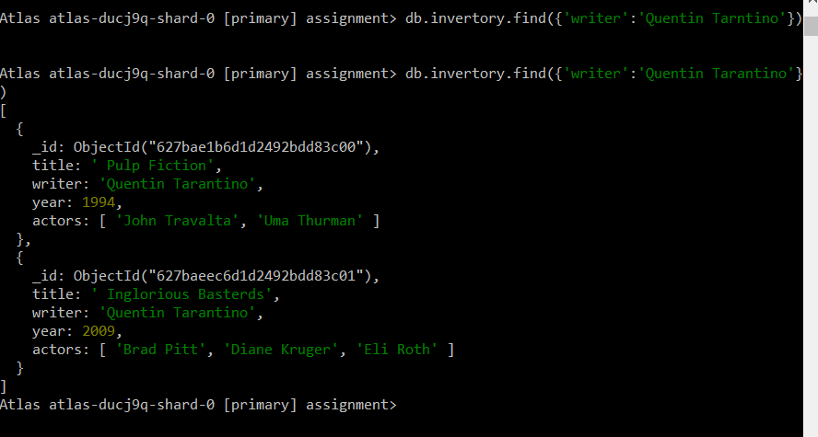

**3. get all documents where actors include "Brad Pitt"**

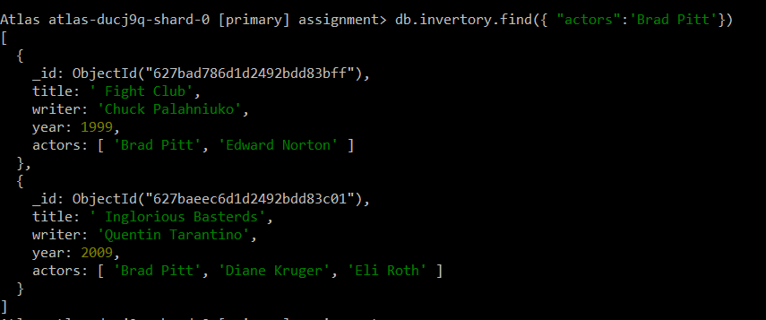

**4. get all documents with franchise set to "The Hobbit"**

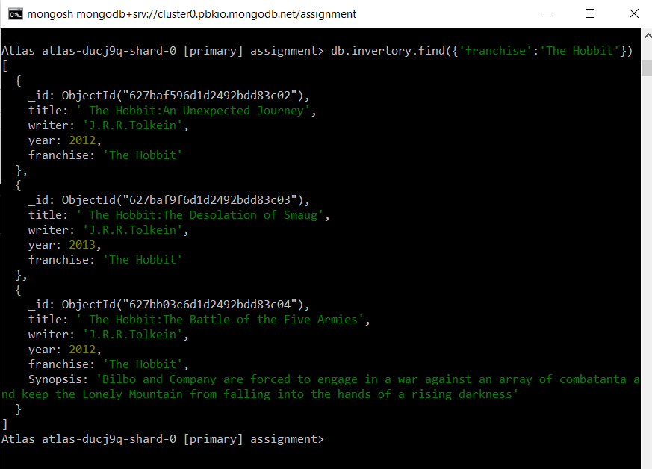

**5. get all movies released in the 90s**

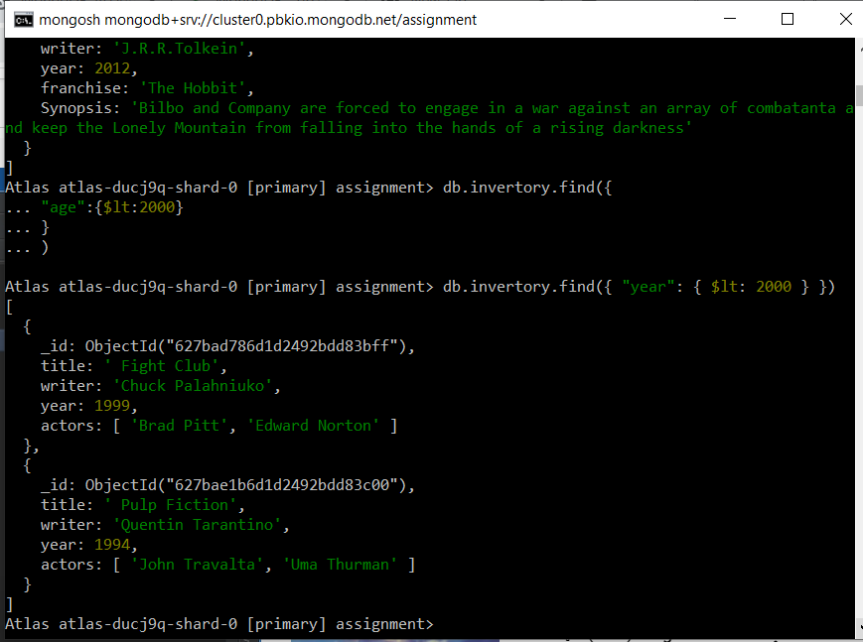

**6. get all movies released before the year 2000 or after 2010**

**Update Documents**

**1. add a synopsis to "The Hobbit: An Unexpected Journey" : "A reluctant hobbit, Bilbo Baggins, sets out to the Lonely Mountain with a spirited group of dwarves to reclaim their mountain home - and the gold within it - from the dragon Smaug."**

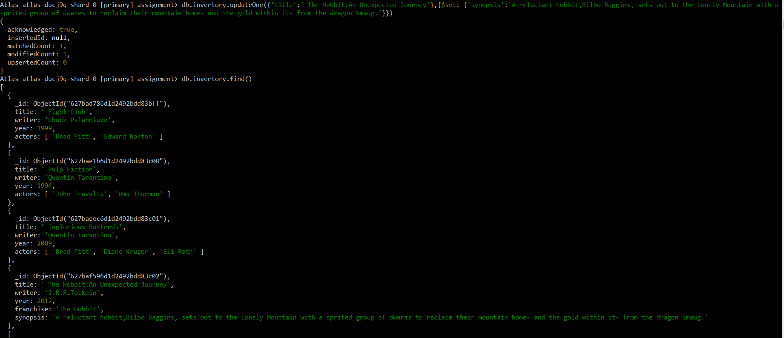

**2. add a synopsis to "The Hobbit: The Desolation of Smaug" : "The dwarves, along with Bilbo Baggins and Gandalf the Grey, continue their quest to reclaim Erebor, their homeland, from Smaug. Bilbo Baggins is in possession of a mysterious and magical ring."**

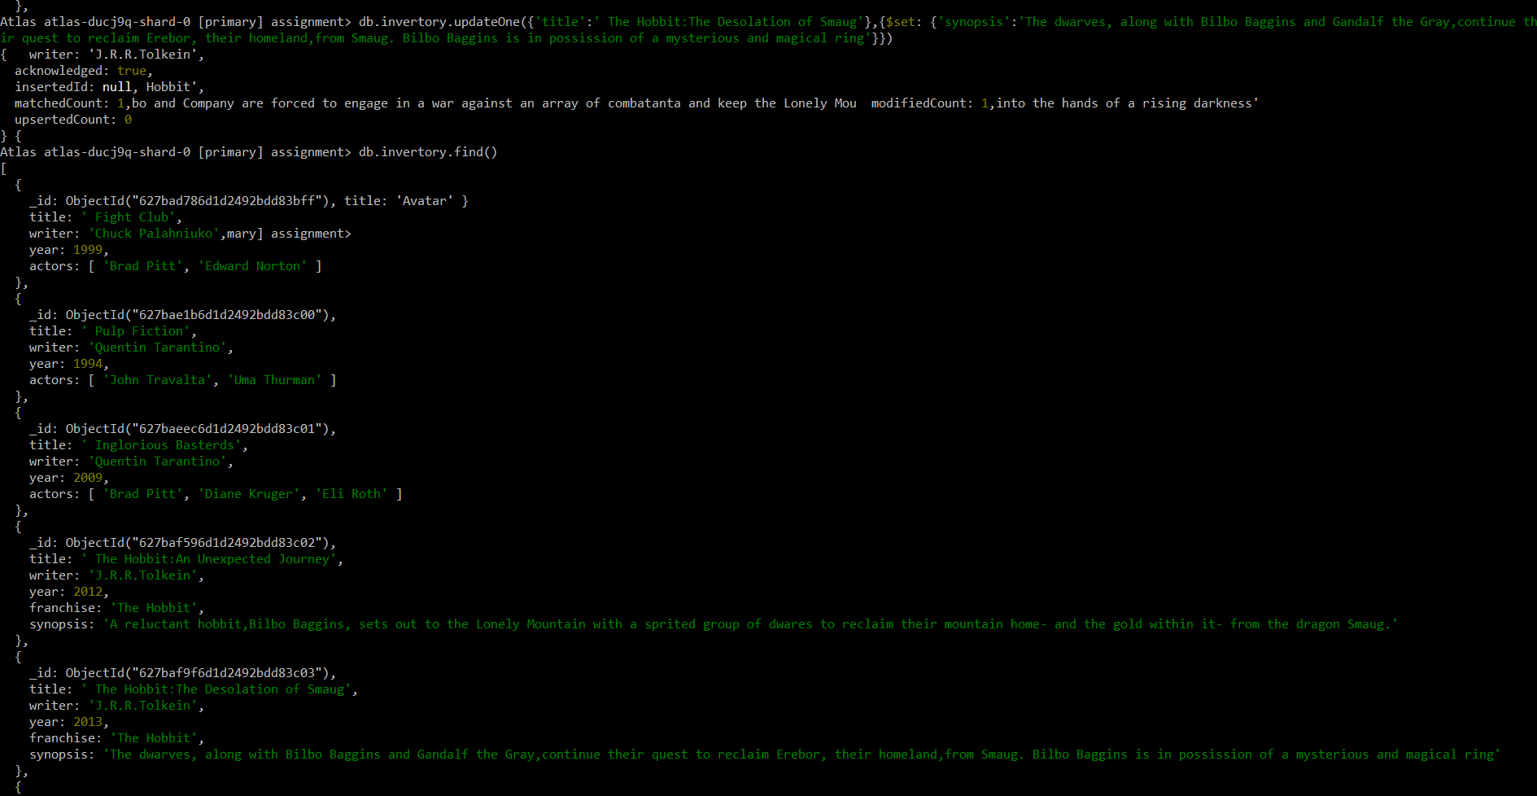

**3. add an actor named "Samuel L. Jackson" to the movie "Pulp Fiction"**

